Database Design
Goal of design is to generate a formal specification of the database conceptual schema.
Methodology:
Use E-R model to get a high-level graphical, conceptual view of the essential components of the enterprise and how these components are related
We later then convert the E-R diagram to SQL DDL, or whatever database model you are using
E-R Model is not SQL-based. It's not tied to any particular logical implementation of a DBMS. It is a conceptual and semantic model, which attempts to capture meanings rather than an actual implementation.
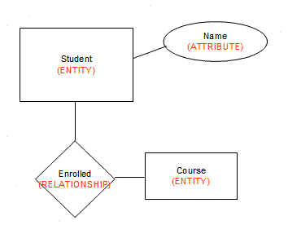
DO NOT THINK OR START WITH TABLES--YOU WILL BE MISGUIDED ON RELATIONSHIPS AND SOME ATTRIBUTES.
The E-R Model:
The enterprise is viewed as set of
- Entities
- Relationships among entities
Symbols used in E-R Diagram
- Entity – rectangle
- Attribute – oval
- Relationship – diamond
- Link - line
We model the potential relationship. Not all entities from a set necessarily connect/relate to another entity in another set.

Entities and Attributes:
Entity: an object that is involved in the enterprise and that be distinguished from other objects. (Not shown in the ER diagram--is an instance)
- Can be person, place, event, object, concept in the real world
- Can be physical object or abstraction
- Ex: "John", "CSE305"
Entity Type or Set: set of similar objects or a category of entities; they are well defined (akin to an OO class).
- A rectangle represents an entity set
- Ex: students, courses
- We often just say "entity" and mean "entity type"
Attribute: describes one aspect of an entity type; usually [and best as] a single value and indivisible (atomic)

Represented by oval on E-R diagram
Ex: name, maximum enrolment
May be multi-valued – use double oval on E-R diagram
May be composite – attribute has further structure; also use oval for composite attribute, with ovals for components connected to it by lines
May be derived – a virtual attribute, one that is computable from existing data in the database, use dashed oval. This helps reduce redundancy.
One or composite set may be designated a key (later)

Entity Types
An entity type is named and is described by set of attributes
- Student: Id, Name, Address, Hobbies
Domain: possible values of an attribute.
- Note that the value for an attribute can be a set or list of values, sometimes called "multi-valued" attributes
- This is in contrast to the pure relational model which requires atomic values
- E.g., (111111, John, 123 Main St, (stamps, coins))
- Key: subset of attributes that uniquely identifies an entity (candidate key)
Keys
Superkey: an attribute or set of attributes that uniquely identifies an entity--there can be many of these
Composite key: a key requiring more than one attribute
Candidate key: a superkey such that no proper subset of its attributes is also a superkey (minimal superkey – has no unnecessary attributes)
Primary key: the candidate key chosen to be used for identifying entities and accessing records. Unless otherwise noted "key" means "primary key"
Alternate key: a candidate key not used for primary key

Foreign key: term used in relational databases (but not in the E-R model) for an attribute that is the primary key of another table and is used to establish a relationship with that table where it appears as an attribute also.
So a foreign key value occurs in the table and again in the other table. This conflicts with the idea that a value is stored only once; however, the idea that a fact is stored once is not undermined.
Graphical Representation in E-R diagram
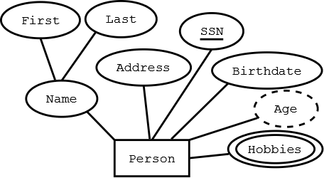
Rectangle -- Entity
Ellipses -- Attribute (underlined attributes are [part of] the primary key)
Double ellipses -- multi-valued attribute
Dashed ellipses-- derived attribute, e.g. age is derivable from birthdate and current date.
Cardinality of Relationships
Cardinality is the number of entity instances to which another entity set can map under the relationship. This does not reflect a requirement that an entity has to participate in a relationship. Participation is another concept.
One-to-one: X-Y is 1:1 when each entity in X is associated with at most one entity in Y, and each entity in Y is associated with at most one entity in X.
One-to-many: X-Y is 1:M when each entity in X can be associated with many entities in Y, but each entity in Y is associated with at most one entity in X.
Many-to-many: X:Y is M:M if each entity in X can be associated with many entities in Y, and each entity in Y is associated with many entities in X ("many" =>one or more and sometimes zero)
